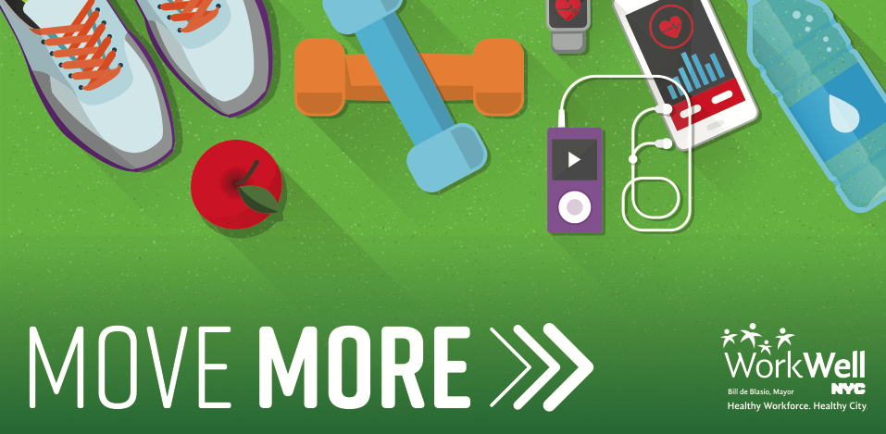
Hello insert agency employees,

Are you ready to Move More?!

This Spring, insert agency will be partnering with WorkWell NYC to offer free insert class type classes here at our worksite for 10 weeks!

Classes will be offered every insert day of week at insert time starting insert day.

To reserve your spot in class, please email insert contact information.

**Be sure to sign up by insert deadline date as spots are limited and will fill up quickly**

Let’s get moving!

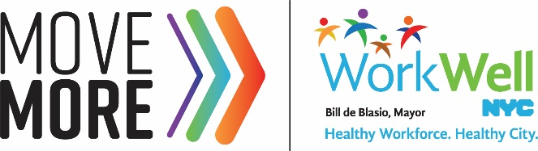
nyc.gov/workwellnyc | workwell@olr.nyc.gov

