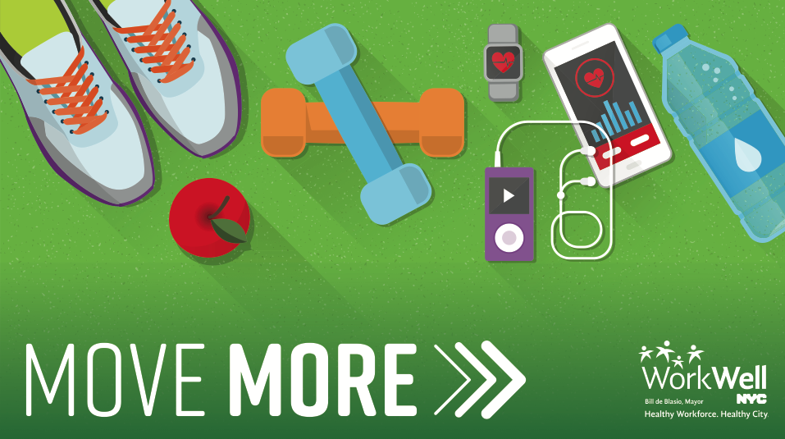

Please email **insert contact info here** to reserve your spot in the class.

**De-Stress with Chair Yoga**

Gentle Seated Workout

**Thursdays @ 1:00pm-2:00pm**

October 16-December 20 / location

[Insert Agency Logo Here]