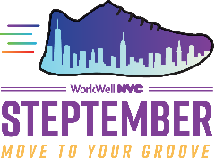 | STEPtember Move To Your Groove Challenge​  Join me and thousands of City employees in the STEPtember Walking Challenge.​  Can you hit 8,000 steps every day? Register by 9/15 at nyc.gov/steptember.

