Promote the STEPtember challenge by copy and pasting the following text into your email signature:

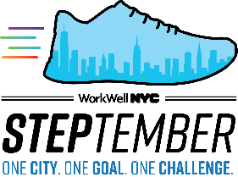
One City. One Goal. One Challenge.
Join me and thousands of City employees in the STEPtember 2020 Walking Challenge. Register by 09/13 at nyc.gov/steptember.

