Email template #3: Don’t forget to sign up! (suggested send date: the week of your event)
Subject line: Don’t forget to sign up for your free screening!

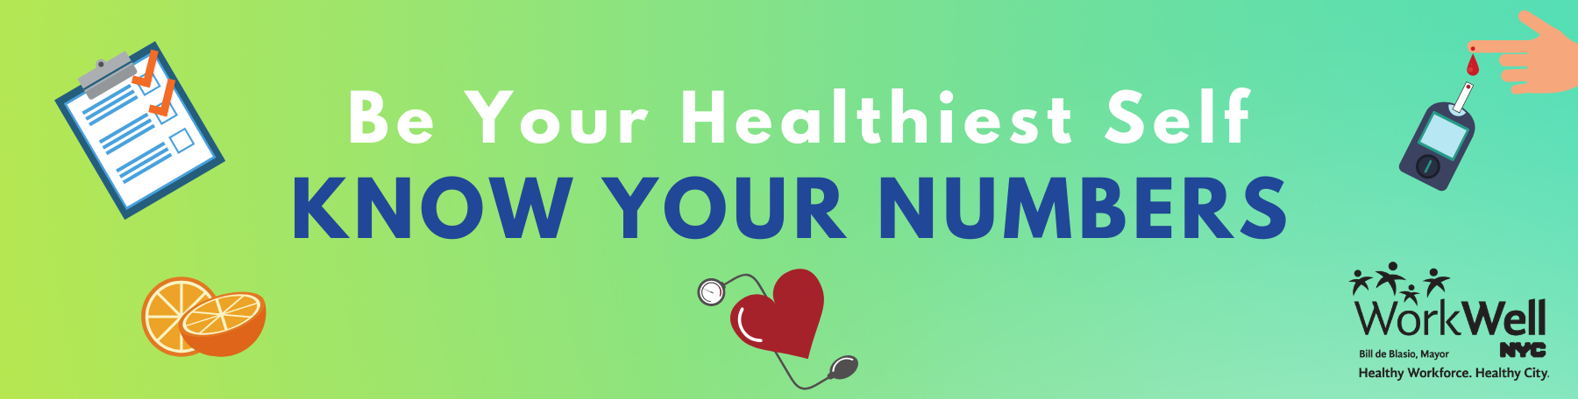
Do you know your numbers? Find out this week:

[Agency/location name]
[Date, Time]
[Location – room/address]

Knowing your numbers can help you learn more about your health and if you may be at risk for heart disease, diabetes, or other health problems. Come learn your blood pressure, BMI, waist circumference, and pre-diabetes risk and talk with a nurse about your results.

Sign me up! Make an appointment here (username workwell and password nyc).
- Try to arrive a few minutes before your appointment time, if possible.
- To save time, you can print out your paperwork in advance and bring it with you.

Not sure of your schedule? Walk-ins are welcome.
- Priority will be given to pre-registered employees.

Questions? Contact [Coordinator name] at [Coordinator email/phone]

Email template #4: Screenings are happening today (suggested send date: morning of event)
Subject line: TODAY: Health screenings at [agency/worksite name]!

Take action – today!
Knowing your numbers can help you better understand your health and if you may be at risk for heart disease, diabetes, or other health problems.

WorkWell NYC is here today to provide free blood pressure, BMI, and pre-diabetes screenings:

[Agency/location name]
[Date, Time]
[Location – room/address]

Priority will be given to pre-registered employees, but walk-ins are welcome!
- Try to arrive a few minutes before your appointment time, if possible.
- To save time, you can print out your paperwork in advance and bring it with you.

Questions? Contact [Coordinator name] at [Coordinator email/phone].

Email template #5: During your event (suggested send date: once event starts)
Subject line: Happening RIGHT NOW: free health screenings!

LAST CALL for blood pressure, BMI, and pre-diabetes screenings!
Take action – know your numbers today!
Screenings will be available until [end time] at [location].
Walk-in spots are still available!

Stuck in a meeting? There are many other ways to know your numbers:
- Find a blood pressure screening location near you
- Visit your health care provider or find an in-network physician here

Questions? Contact [Coordinator name] at [Coordinator email/phone]

